

**IQRA University, Islamabad, Chak Shahzad**

**Project Proposal  
(SCOPE DOCUMENT)**

**for**

**Frustal Field Reservation System**

***By***

**Ehtisham Naveed CK-FA21-110734**

**Saadullah CK-FA21-110420**

***Supervisor***

***Mam Nazish Bashir***

**Department of Computing & Technology**

***Bachelor of Science in CS***

**SCOPE DOCUMENT REVSION HISTORY**

|  |  |  |
| --- | --- | --- |
| **No.** | **Comment** | **Action** |
|  |  |  |
|  |  |  |
|  |  |  |
|  |  |  |
|  |  |  |
|  |  |  |

**Supervisor Signature**

**Date:**

# **Introduction**

The Futsal Field Reservation System is an innovative web-based platform that seeks to ease the process of booking futsal grounds in Rawalpindi and Islamabad. There are a lot of futsal grounds in Rawalpindi and Islamabad, but if a local team wants to book a slot for their football game in any of these grounds, first they will have to go through each and every ground owner's contact information to inquire if a slot is available or not. If the slot is already booked then they will have to repeat the entire process again which can prove to be quite the tedious process. Moreover, if they do find a slot they will still need to find players to play against. In this way such hurdles deter people in trying to play a simple game of football. Futsal Field Reservation System is a service that will enable local football teams to book a pitch for their football games while at the same time helping ground owners manage the bookings for their facilities. Our platform offers a solution that streamlines facility management for providers while catering to the general public who want to book, practice, and play on sports facilities. Our mission is to provide the local football players of the twin cities an opportunity to play a proper and professional game of football by minimizing the ground booking hurdles that most of the players residing in our country face. And help turn ground renting into a lucrative business for the ground owners. Our system will also provide an academy option whereby people looking to learn, practice, and hone their football skills can easily register through our website for academies of whatever ground is offering. We also aim to set up a donation system for impoverished players who wish to play the game but are unable to do so because of various financial issues. So, that all have equal opportunities. We are committed to improving public access to football sports facilities.

# **Problem description**

This is very tiresome for players and also for the ground owners in Pakistan due to the fact that there is no main hub or any central spot where one can book or schedule a slot for Futsal and Football ground. Players have to personally call all ground owners for any available slot, which is very tedious and time-consuming. At times, even if a player somehow manages to get a slot, he might face issues finding the opponents to play. This translates into facility mismanagement and loss of revenues for the ground owners, who have to depend on sporadic bookings through personal contacts. These issues discourage players from participating in regular games and make it harder for owners to turn their facilities into sustainable businesses. Besides, aspiring players, especially from underprivileged backgrounds, face additional barriers to accessing grounds or training opportunities.

This chaotic process is not only limiting the access of football as a sport but also causes further hindrance to the development of the local football culture and community involvement. The time has come that an improved solution to all these barriers must be brought in to create a more organized, inclusive football environment.

# **Proposed solution**

The Futsal Field Reservation System aims to provide an integrated platform that will ease the task of booking futsal grounds and managing the facilities related to the booking process. The ground owner will be able to put up his facility on the portal, listing available slots and giving the best service to book those slots with less hard work to increase manifold revenues. The grounds can be searched location-wise and time-wise, slot booking is easily done, and even teams can be contacted for match arrangement in an easy manner. All this is done without the players needing to call many ground owners and the ground owners concentrate on developing their services.

Moreover, it introduces some features like academy registration, enabling all aged players to register themselves in different football training and skill enhancement programs, which facility owners will offer. Also, there is a donation system that may help the underprivileged player as not every player can afford to come into the field for playing and getting equal opportunities. Addressing both players' and owners' needs, this system improves access to football while promoting local sportive ecosystems: more professional and orderly space for the game.

# **Objectives**

The major aim of the Futsal Field Reservation System is to simplify the process of booking the futsal grounds on the part of the players and managing the facility for the ground owners. Thus, by offering an easily accessible online platform, the players will be able to search for the availability of the grounds, book them according to their preference, and get connected with other teams for matches.

* **Smoothen the Booking Process:** Provide an easy platform where players can search and book futsal grounds with ease, based on location and availability.
* **Smarter Facility Management:** Provide ground owners with a system to manage bookings, track reservations, and optimize revenue.
* **Promote Football Culture:** Encourage participation in the sport through eliminating logistical hindrances for players and convenient access to grounds and matches.
* **Skill Development:** Provide an academy registration feature for players to learn and enhance their football skills through some organized training programs.
* **Support:** Introduce a donation system to help underprivileged players access facilities and take part in football activities.
* **Scalability:** The twin cities of Rawalpindi and Islamabad would be targeted initially, but keeping in mind the vision for nationwide expansion and integration for national leagues.
* **User Satisfaction:** The overall experience of players and ground owners by providing an efficient, reliable, and user-friendly system.
* **Modernize the Booking System:** Replace traditional and obsolete ways of manual booking with a technology-driven solution, showcasing the emerging trends in sports management in today's world of digitization.

# **Scope of project/research**

The scope of the Futsal Field Reservation System is first focused on the twin cities of Rawalpindi and Islamabad, where it will provide services to the local football players and ground

owners. This project is aimed at developing a centralized online platform that will simplify the

process of booking futsal grounds by providing an efficient solution to players and ground owners alike. It will facilitate finding available grounds, booking the slots, and contacting a team, while the ground owners can register facilities, manage bookings, and consequently increase revenue.

* **Geographic Focus:** The platform will focus on the twin cities of Rawalpindi and Islamabad, targeting local football players and ground owners.
* **Booking System:** The platform allows players to find and book futsal slots and connect with other teams to arrange their matches.
* **Management of the Ground Owner:** This will enable the ground owner to register his facilities, manage bookings, and keep track of reservations so that he may optimize his income.
* **Academy Registration:** The system will have the facility for players to register for football academies offered by the facility owners, which would support the development of skills.
* **Donation System:** The system will introduce a donations feature to help under privileged players who may not pay to book grounds or buy football activities.
* **Web and Mobile Access:** The web and mobile access will ensure ease of use for the broad audience that will be using the platform.
* **Scalability:** The project thus starts focusing on twin cities to then scale nationwide, with a road-map of integrating national leagues and tournaments.
* **Long-term vision:** More feature integration's in future development; partnerships with local football organizations, taking into consideration platform usage at the national level.
* **Focus of Research**: The study will focus on feasibility analysis with regard to expansion based on needs determined by the football players, ground owners, and the football community at large, across Pakistan.

# **Modules description**

Modules of the project will contain:

### User Modules:

### **1.Authentication:**

### Users Login and Gain Access to Specific system functionalities.

### **2.User Data:**

### Manages User Profiles, Preferences, and Personal information.

### **3.Academy Data:**

### Allows Academies to manage reports, submit consent, and Register users.

### **4.Ground Owners Portal:**

### Enables ground owners to register grounds, manage details, and Bookings.

### **5.Teams Portal:**

### Facilities team management, including sharing data, managing roles, and creating schedules.

### **6.Teams Data:**

### Stores and Processes team specific data, such as event schedules and roles.

### **7.Bookings Module:**

### Let User’s book grounds, View Availability, and get bookings -related notifications.

### **8.Donations:**

### Handles user Donations for events or academy-related causes.

### **9.Alerts:**

### Notifies users of Updates, upcoming events, and important information

### **10.Chat:**

### Enables Communication between users and Ground owners.

### **Admin Modules:**

### **1.Admin Dashboard:**

### Central Dashboard to approve or reject reports, registrations, and consents.

### **2.Authentication Management:**

### Oversees login credentials and controls user access permissions.

### **3.Data Oversight:**

### Allows the admin to access , edit or delete Users Data, Academy Data, Ground Owner’s Data, and Teams Data.

### **4.Ground Management:**

### Monitor’s ground Registrations and Booking Approvals.

### **5.Event and Notification Management:**

### Administers Alerts and updates for all users to ensure timely communication.

### **6.Donation Oversight:**

### Tracks donations and ensures proper utilization for events or causes.

### **Combined Modules with Linking and Purpose:**

|  |  |  |
| --- | --- | --- |
| **Linked Modules** | **How They Link** | **Why They Link** |
| Authentication(User & Admin) | User login, admins oversee  access control. | Ensure secure access and  proper user roles. |
| User Data & Admin Panel | User manages profiles, admins can edit/approve  data. | Maintains data integrity and resolves inconsistencies. |
| Academy Data & Admin Panel | Academies submit data for  admin approval. | Ensure compliance and data  accuracy. |
| Ground Owners Portal & Bookings & Admin Panel | Ground owners manage  grounds and bookings; Admin monitors for disputes. | Streamlines booking processes while maintaining oversight. |
| Teams Portal & Teams data & Admin Panel | Teams manage schedules/roles, admins audit  or resolve conflicts. | Ensure coordination between teams and stakeholders |
| Bookings & Teams Portal & Ground Owners Portal | Teams requests bookings, ground owners approve. | Facilities seamless bookings  without admin intervention in routine cases. |
| Donations & Admin Panel | Users donate, admins track  and allocate funds. | Maintains transparency in  resource allocation. |
| Alerts & Admin Panel & UserModules | Admins manage notifications  and sent to users. | Keeps users informed of  updates events, or bookings. |
| Chat & Teams Portal & Ground Owners Portal | Chat Allows direct interacting;  Admins moderate if needed. | Enhances Communication and  reduces dependency on admin for minor coordination. |

# **Strengths and limitations of the proposed project**

|  |  |
| --- | --- |
| **Strengths** | **Limitations** |
| * **Easy Booking:** It saves players from wasting time in contacting multiple ground owners to book a slot. * **Better Management for the Owners:** Ground owners would be able to manage bookings with much more ease to fill slots and increase the income thereof. * **Extra Features:** Special features include academy registration for training,donations for underprivileged players provided by the system. * **Supports Football Growth:** Makes playing football more accessible and encourages more participation. * **Easy to operate:** user-friendly for the ground owners and players. * **Future Expansion:** The platform can expand to increasing numbers of cities, eventually covering national leagues. * **Modern Solution:** Replaces traditional systems of booking with an online method. | * **Limited availability:** The system will initially be available in Rawalpindi and Islamabad only. * **Internet Required:** Users need internet access to use the platform, which may not be available to everyone. * **Learning Curve:** Some of the users, especially those not used to technology, may take time to adapt * **Local Competition:** If other platforms with similar features emerge, it could impact adoption. * **Maintenance Cost:** The system needs regular updating and support, which entails resources. * **Security Risks:** The protection of users' data and payments is considered crucial and quite challenging. * **User Participation Needed:** The system’s success depends on ground owners and players actively using it. * **Financial Barriers**: Some players might still not afford booking with a donation system in place.. |

# **Software Process Methodology**

# It is for that reason that this project, Futsal Field Reservation System, chooses the software development process of Agile Methodology, since it is possible with Agile to be iterative and incremental, thus working more flexibly, continuously collaborative, so that receiving feedback and refinement of specifications may be possibly done throughout the lifetime of the project.

Key Features of Agile that can be Applied in This Project:

**Iterative Development:** This approach breaks the project down into smaller, manageable pieces of work called iterations or sprints, each delivering a usable component of the system.

**Customer Collaboration:** Periodic feedback from ground owners, players, and stakeholders puts the system in a realistic position to meet user needs.

**Flexibility:** Agile allows agility towards changing necessities because it provides the reality of evolving systems with every single user's demand or requests.

**Faster Time-to-Market:** Prioritized development ensures the early delivery of high-impact features such as ground booking and team registration.

**Continuous Testing:** Testing in each sprint makes the platform qualitative and bug-free.

**Transparency:** The team makes regular updates, sprint reviews, and progress demonstrations a common occurrence.

# **Tools and technology**

|  |  |  |  |
| --- | --- | --- | --- |
| **Tools and Technologies** | **Tools** | **Version** | **Rationale** |
| Frontend | HTML | N/A | Markup language for structuring the web pages. |
| Frontend | CSS | N/A | Styling the web pages for enhanced user interface. |
| Frontend | React JS | N/A | Open-source Javasript library for building user interfaces. |
| Frontend | PWA | N/A | Making the web app mobile friendly and app-like. |
| Backend | Node JS | N/A | Backend runtime environment for server side logic. |
| Database | MongoDB | N/A | NoSQL database for managing unstructured data efficiently. |
| Development Framework | Express JS | N/A | Framework for building web applications on NodeJS. |
| Communication Tools | Chat Module | N/A | Enables communication between ground owners and teams. |

# **Project stakeholders and roles**

|  |  |
| --- | --- |
| **Project Sponsor** | IQRA University, Islamabad, Chak Shahzad |
| **Stakeholder** | * Ehtisham Naveed(CK-FA21-110734) * Saadullah (CK-FA21-110420)   Project Supervisor Name: Ms. Nazish Bashir  Final Year Design Project Committee: Evaluation of project |

# **Team members individual tasks**

|  |  |  |
| --- | --- | --- |
| **Student Name** | **Student Registration Number** | **Responsibility/Modules** |
| Saadullah | CK-FA21-110734 | Module1: Responsive front-end technologies such as HTML, CSS, for user interfaces  Module2: Admin interface developed in HTML, CSS  Module 3: ensure a seamless and user- friendly interface.  Module4:UserAuthentication, user friendly interface |
| Ehtisham Naveed | CK-FA21-110420 | Module 1: Backend Integration  Module 2: Data integration using Node.js  Module3:User Authentication,user-friendly interface  Module4:Managing Data using Database |

# **Data gathering approach**

**Interviews with Footballers and Teams:** Identify pain points associated with booking grounds and liaising with other teams.

**Understand feature usage preferences:** browsing for available slots, scheduling matches, and finding opponents.

**Focus Groups:** Organize small group discussions among players and ground owners about desired features and determine the priorities of system functionalities.

**Competitor Analysis:** Study similar websites like Pitch-booking of the UK and Gwsports from India to know the current best practices and what features can be taken on or improved for the local market.

# **Domains Understanding**

**Web Tools:** HTML, CSS, and JavaScript. The developed application will serve as web-based Futsal reservation grounds for Football players alone. This project focuses on simplifying the process of reserving futsal arenas, teams, or even players and providing a highly functional interface using web technologies.

**JS Framework:** Javascript gives a dynamic and component- based structure for building a responsive and scalable front-end of the platform. Allows development of mobile-friendly features, making the platform accessible and app-like on smartphones.

**Integration of databases:** MongoDB is a NoSQL database that efficiently manages unstructured data, thus permitting real-time operations.

# **Feasibility Analysis:**

An overall study of the project has been carried out, and the findings have been listed in this report. The feasibility of "Futsal Field Reservation System" can be ascertained on the following assessments:

1. **Technical Feasibility:**

The project is technically feasible due to the availability of proven tools and technologies for development:

**Frontend Technologies:** The interface would be user-friendly, cross-platform, with HTML, CSS, React JS, and PWA.

**Back-end and Database:** Node.js, ExpressJS, and MongoDB have proven a reliable choice in developing scalable, robust, and efficient systems.

**Integration Capabilities:** Team coordination, booking, academy management, and donation modules can be integrated seamlessly.

**Testing and Deployment:** With current Agile, there is always testing and the possibility for improvement in continuous development.

**Support:** The team has access to expertise in software development, ensuring any challenges can be addressed efficiently.

1. **Financial Feasibility:**

|  |  |  |
| --- | --- | --- |
| **Resource Name** | **PKR(Price)** | **Source** |
| **Development Tools** |  |  |
| - ReactJS (Open-source) | 0 | Free Open-source Software |
| - NodeJS (Open-source) | 0 | Free Open-source Software |
| - MongoDB (Free Tier) | 0 | Free Tier from MongoDB Provider |
| - ExpressJS (Open-source) | 0 | Free Open-source Software |
| **Development Hardware** |  |  |
| - Existing Laptops | 0 | Personal/University-provided |
| - Internet Connectivity | 0 | University Wi-Fi |
| **Hosting and Deployment** |  |  |
| - Free Hosting (e.g., Vercel, Netlify) | 0 | Free Hosting Services |
| - Free Domain (e.g., .tk or .ml) | 0 | Freenom or Other Free Domain Providers |
| **Marketing and Promotion** |  |  |
| - Social Media Ads (Basic Campaign) | 5,000 | Social Media Platforms |
| **Testing and Maintenance** |  |  |
| - Community Testing | 0 | Volunteers/Local Football Community |
| - Ongoing Maintenance | 0 | University Student Teams |
| **Miscellaneous** |  |  |
| - Travel for User Feedback | 0 | Local Public Transport (Covered by Volunteers) |

1. **Resources Feasibility:**

**SQL Server:** For database (NoSQL)

**Open Sources Tools:** React JS, Node JS, and MongoDB

**Hosting:** Vercel/ Netlify

1. **Schedule Feasibility:**

**Task Name: Duration Start Date End Date**

**Project Planning:** 1 week 10-Nov-2024 17-Dec-2024

1. **Schedule Feasibility:**

Task Name Duration Start Date End Date

Project Planning 1 week 10-Nov-2024 17-Dec-2024

|  |  |  |  |
| --- | --- | --- | --- |
| **Task Name** | **Duration** | **Start Date** | **End Date** |
| Requirement Analysis | 2 weeks | 18-Dec-2024 | 31-Dec-2024 |
| System Design | 3 weeks | 01-Jan-2025 | 21-Jan-2025 |
| Frontend Development | 4 weeks | 22-Jan-2025 | 18-Feb-2025 |
| Backend Development | 5 weeks | 19-Feb-2025 | 25-Mar-2025 |
| Integration & Testing | 3 weeks | 26-Mar-2025 | 15-Apr-2025 |
| User Testing & Feedback | 2 weeks | 16-Apr-2025 | 29-Apr-2025 |
| Final Modifications | 2 weeks | 30-Apr-2025 | 13-May-2025 |
| Deployment | 1 week | 14-May-2025 | 21-May-2025 |
| Project Closure | 1 week | 22-May-2025 | 29-May-2025 |

This schedule outlines the major project phases, their respective durations, and the planned start and end dates. The project is expected to be completed within approximately six months, with each phase contributing to the overall timely delivery of the system.

1. **Operational Feasibility:**

It defines the operational feasibility as the likelihood of the proposed system performing its functions within the existing organizational environment and meeting the operational needs of the stakeholders: both users, comprising the football players and ground owners, and the system administrators. Operational feasibility involves some major factors that influence the Futsal Field Reservation System in the following ways:

**User Accessibility:**

The system will be web-based, but also accessible on mobile devices to ensure the widest possible access for all potential users, whether football players or ground owners. This meets the needs of diverse users in Rawalpindi and Islamabad, especially those who rely on smartphones.

**Ease of use:**

The design will be user-interactive, intended for both the application's savvy and less savvy use. Training and support for its use by the ground owner to effectively manage bookings or operate the platform will also be provided.

**System Integration:**

The platform will integrate features like booking management, team coordination, academy registration, and donation collection in one interface. This would make operations easier to handle for both players and ground owners by reducing manual tasks and operational overhead.

**Support and Maintenance:**

It will keep updating regularly for smooth functioning; bug fixing is also an important part. Regarding technical issues, getting feedback from users, and implementing improvement in the system, there is going to be a structured support team present.

Only free or low-cost open-source technologies will be relied upon. It goes a long way in ensuring operational sustainability, besides keeping the maintenance costs as low as possible.

**Scalability:**

The online marketplace platform will, at the outset, cater to Rawalpindi and Islamabad; it will be expandable for other cities and localities as per requirements. The system will be designed in such a way that it can easily integrate into the system with new grounds, users, and also national football leagues.

**Security Management, data management:**

The system will follow the basic principles of security: it will ensure that users' data are not compromised, their personal information and payment data. It is impossible to completely protect from security risks, but with well-established technologies-like MongoDB-and secure ways of communication, these risks are reduced.

**System Monitoring:**

Eventually, administrators will be able to observe and manage the system from an admin dashboard to ascertain that any operational issues overbookings or disputes could be identified and resolved to take as little time as necessary to resolve.

# **Gannt Chart**

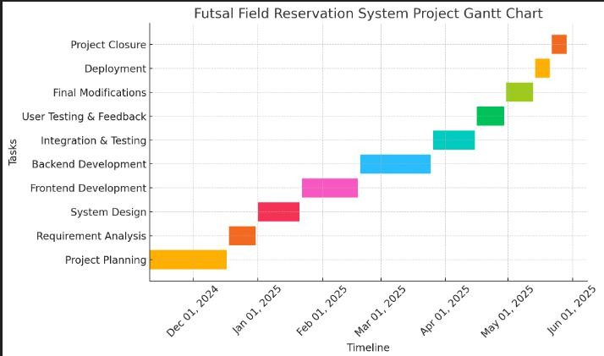

# **Prototype**

* Web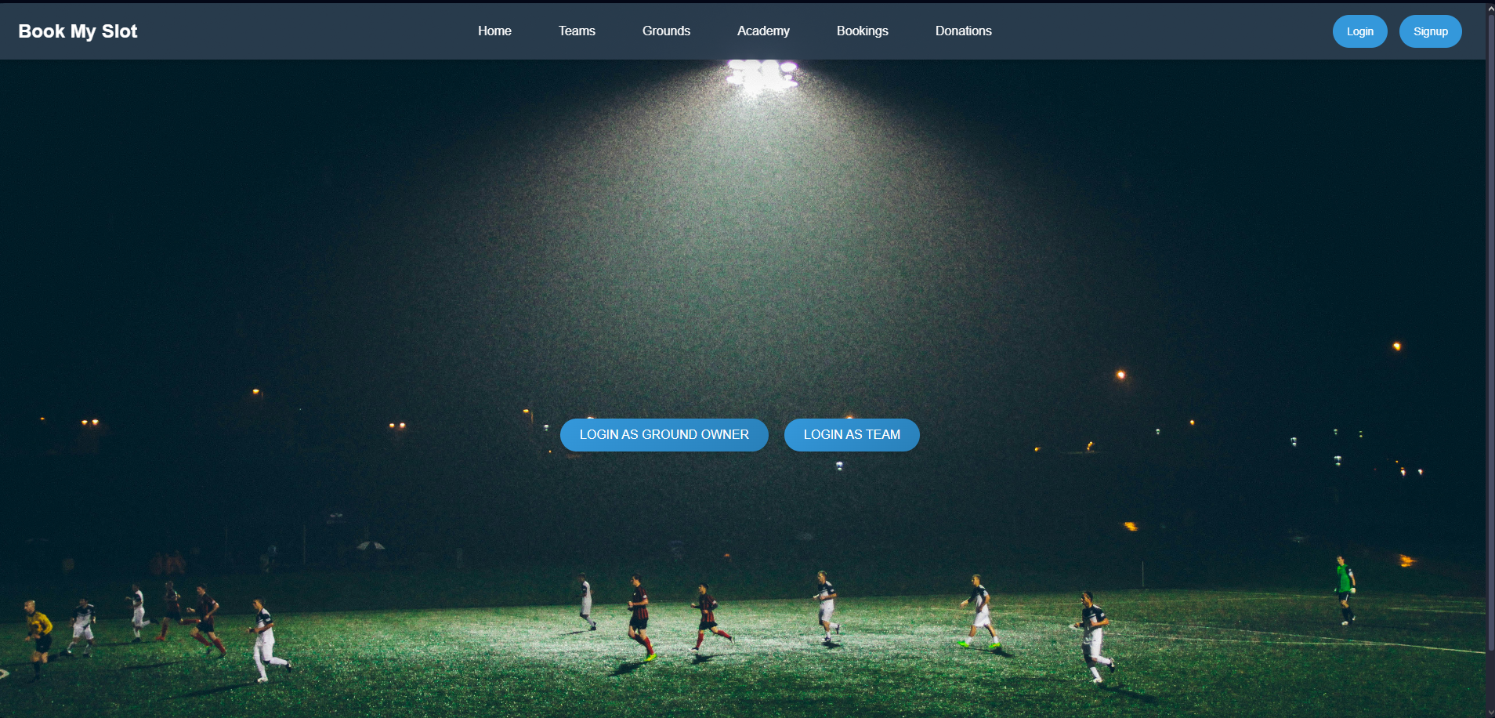

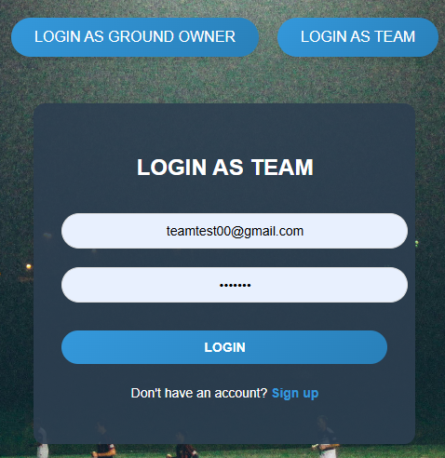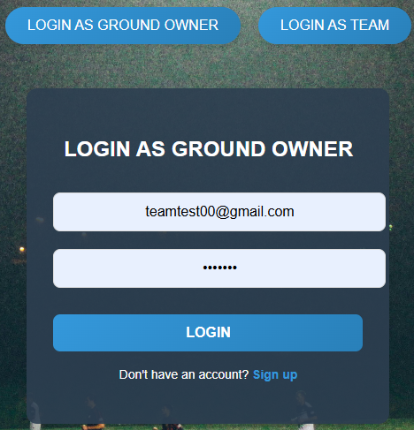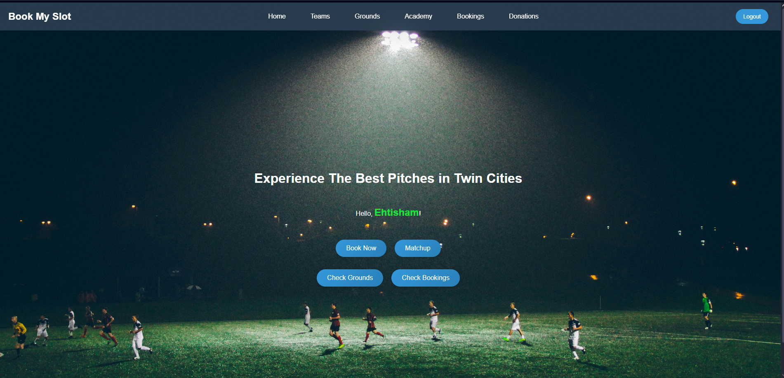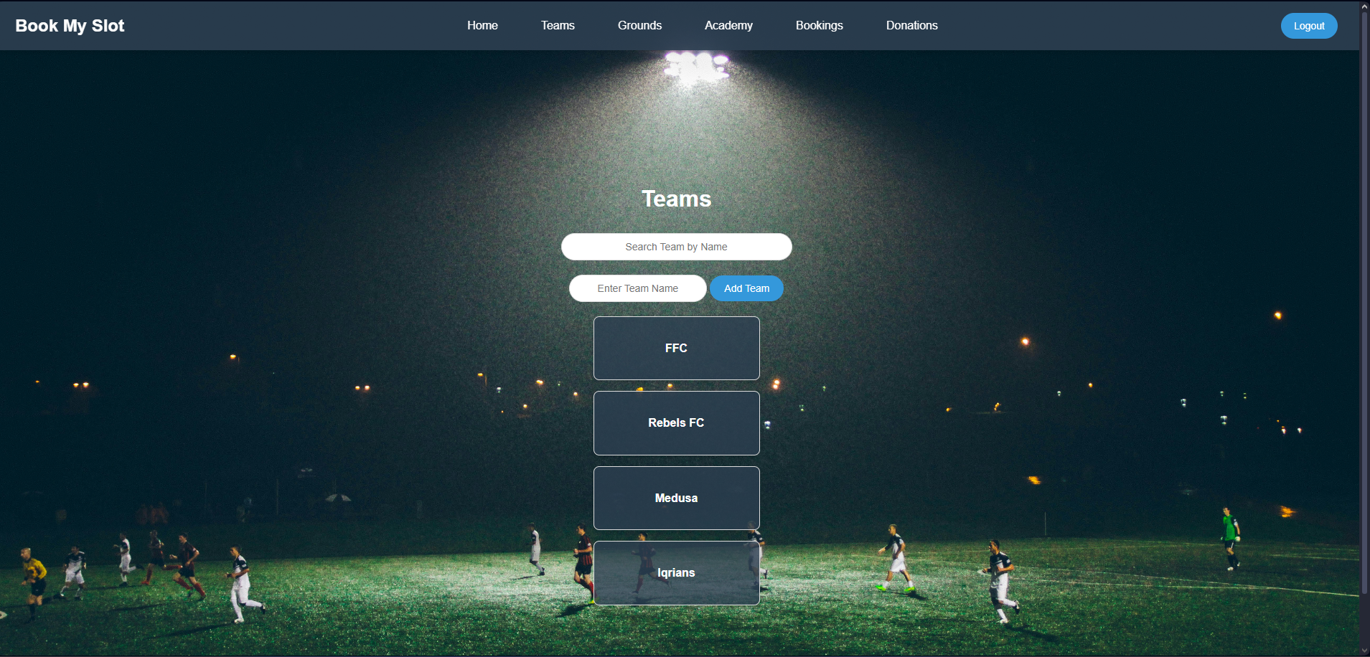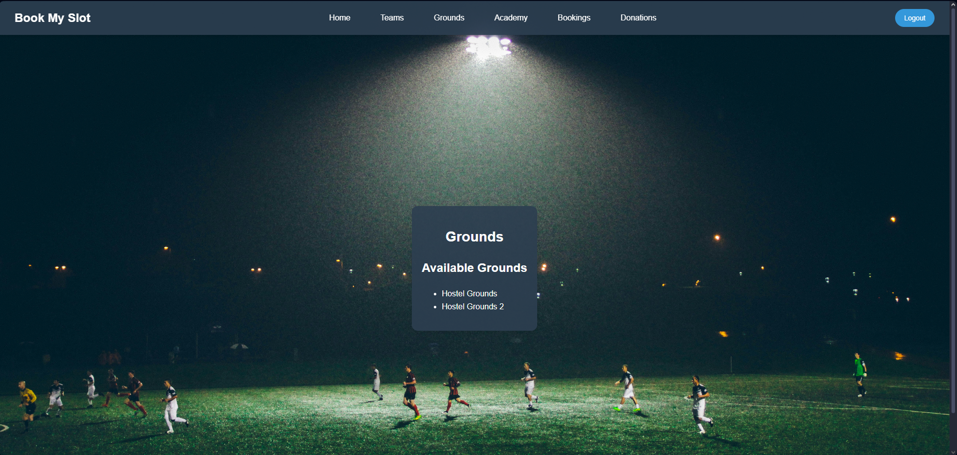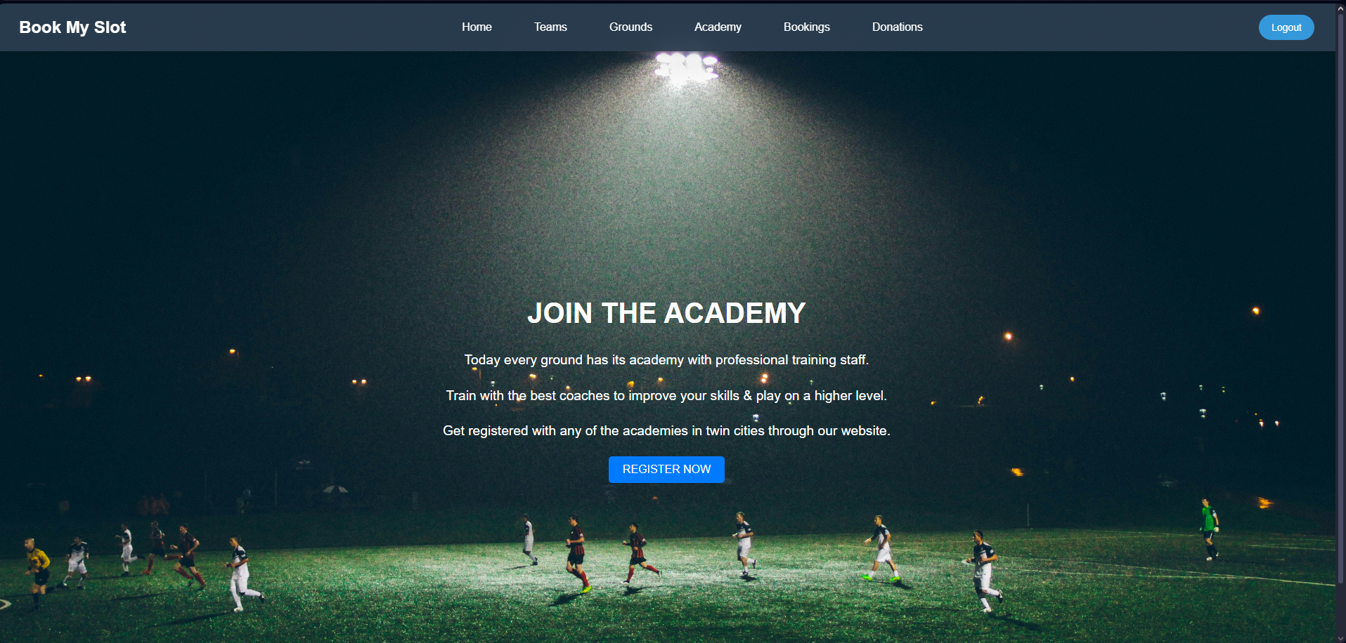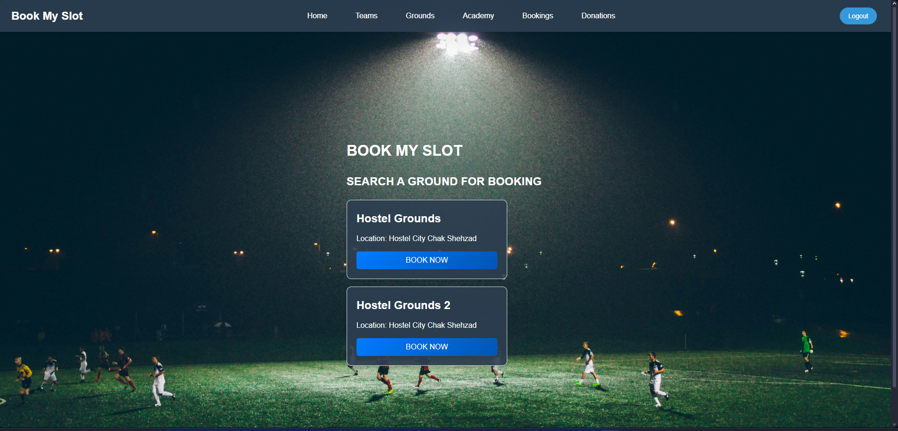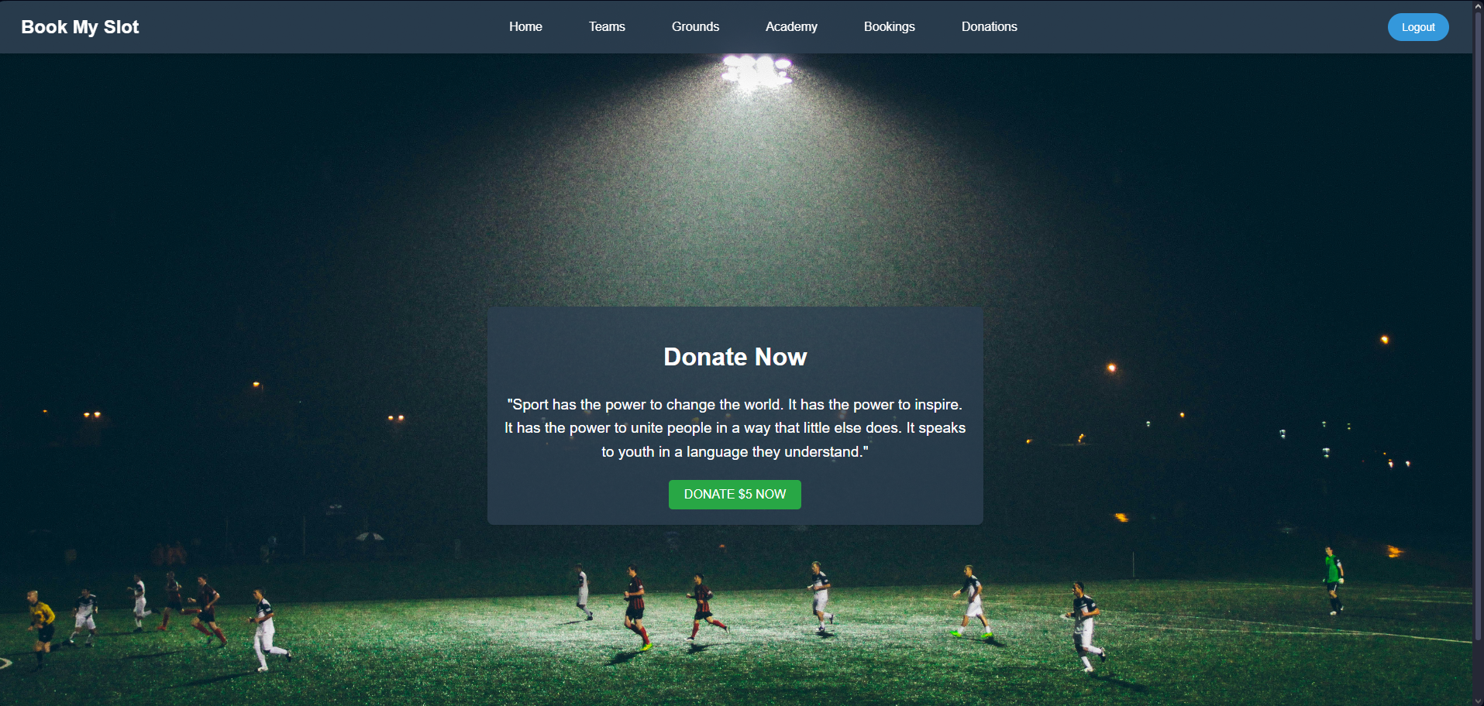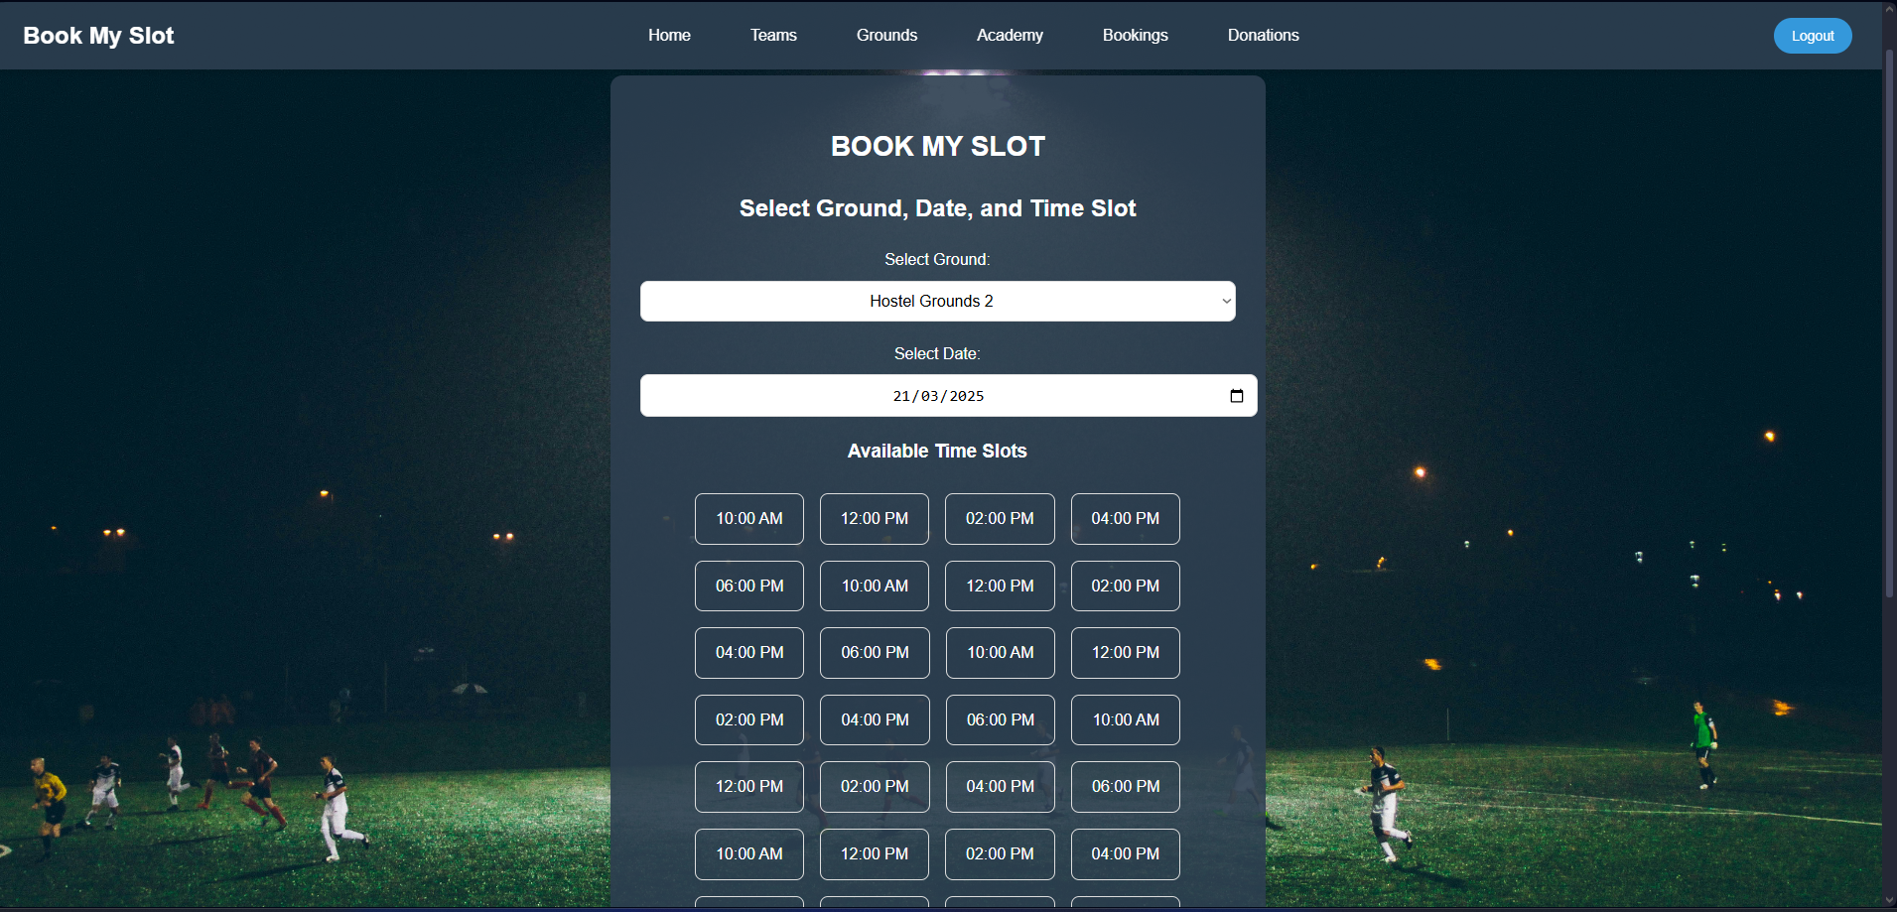

# **Conclusion**

Futsal Field Reservation System is a web service intended to make life easy for both the teams looking for grounds to book in advance and the facility providers to manage the grounds. Therefore, we are offering a single solution by providing one contact point for both teams and the ground owners through which ground owners can list their grounds on our website for easy access by the local teams, who will be browsing and booking the playing fields in their ideal location and at the best times. Teams can take up direct communication with facilitators at the facility or when complications arise.

# **References(for research projects)**

* Pitchbooking (UK). (2023). "How we streamlined football ground booking for sports facilities." Pitchbooking. Retrieved from **[https://www.pitchbooking.com](https://www.pitchbooking.com/)**.
* Gwsports (India). (2023). "Revolutionizing sports facility management through a digital platform." Gwsports. Retrieved from **[https://www.gwsports.com](https://www.gwsports.com/)**.
* MongoDB. (2024). "MongoDB Documentation: Database Features." MongoDB Inc. Retrieved from **<https://www.mongodb.com/docs>**.

# **Palgiarism Report**

Attach the Palgiarism report of your project scope of turnitin tool (http://turnitin.com)